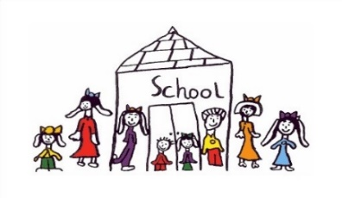
Clayton South Primary School

SCHOOL PHOTOGRAPH PERMISSION FORM

I hereby give my consent for my child to be photographed in a school activity and my child’s photo published/displayed on

Please tick
Classroom/school displays
School newsletter on CSPS web page (first names only)
Other: including local newspaper & outside school events

Permission is granted for the duration of my child/children’s enrolment at CSPS. Written notification is required to the class teacher if circumstances change
_______________________________________________

SCHOOL EXCURSION PERMISSION FORM
I hereby give permission for my child, whose name appears below, to participate in any school activities and excursions which require walking to and from the venue. Providing a teacher is in charge and all reasonable care is taken. I agree in the event of an illness or accident during this excursion, if I cannot be contacted, the teacher in charge has permission to obtain such medical assistance as considered necessary for my child.
I will accept responsibility for any charge involved. I note an excursion includes any teacher supervised activity outside the school grounds.
.
I understand and agree that if I wish to withdraw this authorisation, it will be my responsibility to inform the school in writing.
Permission is granted for the duration of my child/children’s enrolment at CSPS. Written notification is required to the class teacher if circumstances change

Name of Student: …………………………………………………… Class: ……………….

Name of Parent or Guardian: …………………………………………..………….…..………

Signature: ……………………………………………… Date: …………………………………

SCHOOL HEADLICE PERMISSION FORM

Throughout your child's schooling, the school will be arranging head lice inspections of students.
The management of head lice infection works best when all children are involved in our screening program.
The school is aware that this can be a sensitive issue and is committed to maintaining student confidentiality and avoiding stigmatisation.
The inspections of students will be conducted by a trained person approved by the principal and school council.
Before any inspections are conducted the person conducting the inspections will explain to all students what is being done and why and it will be emphasised to students that the presence of head lice in their hair does not mean that their hair is less clean or well-kept than anyone else's. It will also be pointed out that head lice can be itchy and annoying and if you know you have got them, you can do something about it.
The person conducting the inspections will check through each student's hair to see if any lice or eggs are present.
Person's authorised by the school principal may also visually check your child's hair for the presence of head lice, when it is suspected that head lice may be present. They do not physically touch the child's head during a visual check.
In cases where head lice are found, the person inspecting the student will inform the student's teacher and the principal (insert other(s) if required). The school will make appropriate contact with the parents/guardians/carers. Please note that health regulations requires that where a child has head lice, that child should not return to school until appropriate treatment has commenced.
The school may request the completion of an 'action taken form', which requires parents/guardians/carers to nominate when the treatment has started.
This information has been taken from: https://www2.education.vic.gov.au/pal/head-lice/policy

Permission is granted for the duration of my child/children’s enrolment at CSPS. Written notification is required to the class teacher if circumstances change

Name of Student: …………………………………………………… Class: ……………….

Name of Parent or Guardian: …………………………………………..………….…..………

Signature: ……………………………………………… Date: …………………………………

Clayton South Primary School

