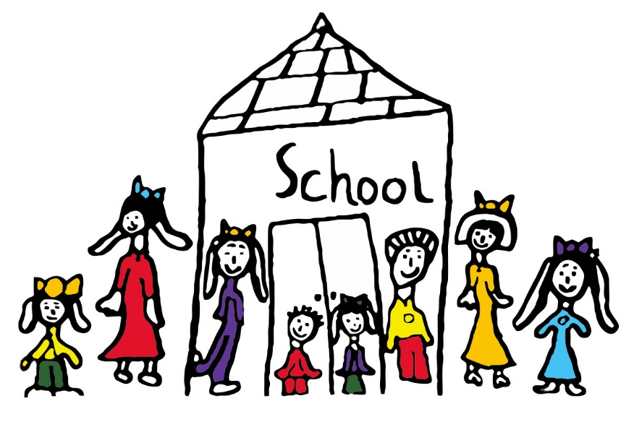
Clayton South P.S.
Online Learning Handbook 2020
Student and Family Edition

Online Learning

Google Classroom - Classroom teachers will post resources and assignments on their year level Google Classroom. This is also the forum for parents to ask questions that might be relevant to the group of children and families in a particular year level. Staff will also email parents, and parents can use teacher emails to reply to and ask educational questions. Staff will only be available to answer between 9am and 4pm each day.

Video Conferencing/feedback: At the time of writing this document, we are not going to engage in video calling/conferencing for feedback with students. This may change in the future and we will update families on the processes if they do. Teachers will provide feedback via Google Classroom.

Prep to Grade 6 Overview

GRADES P-2
The focus of the program should be on literacy, numeracy, play-based learning and physical activity.
In the first stages of these programs, the aim should be to provide literacy activities that take a total of about 45-60 minutes, with 30-45 minutes allocated to each of numeracy, play-based learning and physical activity.
Parents or siblings will not always be able to support tasks that involve complex communications.
· Daily literacy program: activities focussed on reading, writing, speaking and listening. This can include, for example, spoken book recordings.
· Daily numeracy program should include basic counting and measuring activities that can be conducted using everyday materials.
· Daily play-based learning activities. These include free drawing and painting, colouring, folding, collecting, grouping and making and listening to sounds, including, where possible, music.
· Daily physical activities that can be completed indoors, for example, simple exercises and dance movements.

GRADES 3-6
For students in these primary years, the program should focus on literacy and numeracy with a broadening of learning to include the key learning areas and general capabilities.
This can be done through subject-based learning and integrated and inquiry-based activities. Students should also be provided with suggestions for physical activity, for example, simple exercises or simple dance routines.
In the early stages of these programs, the aim should be to provide daily activities that focus on:
· literacy for a total of 45-60 minutes
· numeracy for 30-45 minutes
· physical activities for 30 minutes

The aim should then be to provide learning activities that each week focus on:
· science and technologies, the humanities, the arts, health and languages, with learning activities enabling students to develop the general capabilities of critical and creative thinking, intercultural understanding and ethical understanding as appropriate.
· activities such as guided reflective journal writing or drawing can be used to support students personal and social development.
The aim should be to provide these learning activities for about 30 minutes each day
Instructions for online learning will be posted on Google Classroom or email for parents by the respective classroom teacher or specialist teacher.
All resources, assignments and group communication will happen through Google Classroom.
The day’s learning will arrive at least 30 minutes prior to the scheduled commencement time. All resources for student learning will be available on email and/or Google Classroom. Teachers may deliver lessons via video recordings on Google Classroom.

A typical daily plan for learning might include the following, BUT you need to consider the Departments minimums as outlined above as well as your own family needs:

English 9:00 – 10:00am
Break 10:00 - 10.30am
Maths 10.30 - 11:00am
Break 11.00am - 1.00pm
Specialist lessons 1:00 – 2:00pm
Family Time

Specialist Programs
Specialist programs will be posted on Google Classroom for parents to instruct their children on specialist lessons and activities. A fortnight’s activities will be posted on Google Classroom. Specialist teachers will be available to be contacted on their usual specialist days.
Monday- Whole School Spanish enquiries
Tuesday- Years 3/4 and Foundation P.E.
Wednesday- Years 5/6 P.E. and Visual Arts, 1/2 P.E.
Thursday- Foundation and 3/4 Visual Arts
Friday- 1/2 Visual Arts

Tips For Parents and Carers
- Please note that these are arrangements for online learning.
- The normal requirements apply in relation to student attendance at classes
- Please read through the student protocols with your child, to ensure they understand the online learning and video conferencing (TBC) expectations.
- Please ensure that the children in your care are using their device in a suitable "public" area of your home. Teachers will not engage with your child if they are located in a private space (e.g. a bedroom) in line with Child Safe Standards.
- All students must be attired in appropriate casual clothing and all internet filtering, parent controls and privacy settings must be in place.
- Please understand that there are challenges to online learning and these things should be taken into consideration:
  - The individual student’s ability to learn and work independently
  - The greater need for self-motivation
  - The requirement for students to ignore distractions, including from older/younger siblings and home environment
  - Contact with peers during home learning can also distract from productive activity; conversation is not always collaboration
- The amount of parent and teacher support will be limited.
- Contact with teachers via email and video conference will be different to face-to-face, class discussion
- Online learning will take longer for students to complete
- Organisation of digital folders for creating, saving, filing, storage and retrieval of work (we recommend students use their Clayton South Google Drive for these purposes)
- Please check-in on your child’s online learning – teachers will be communicating the day/week learning to students and parents/carers via email and Google Classroom.
- Please be kind to yourself, your children and our teachers as we are all learning to navigate this online learning and the virtual classroom
- Lesson content is to be used for educational purposes only, and Clayton South’s policies regarding behaviour and use of digital devices etc will apply to all video conferencing lessons. More information available online from e-Safety commission www.esafety.gov.au/about-us/blog/covid-19-keeping-schools-and-learning-safe-online

Copyright: So that we are operating within guidelines, we must ask that you do not share videos we upload

Privacy: Please also keep in mind that privacy relates to all our students and teachers. Please refrain from sharing any clips or images on any social media channels (including WhatsApp) which include images or comments of anyone other than you or your own child. This relates to intellectual property as well. Comments, videos and work samples should not be copied in any way. Consult our schools’ privacy policy at the link below. https://www.education.vic.gov.au/Pages/schoolsprivacypolicy.aspx

ICT Policy: This will come home in the early stages of Term 2.

Online Protocols For Students:

- Use your laptop/ iPad/desktop computer
- Please do not use your personal phone.
- Dress Code - appropriate casual clothing.
- Try to sit at a desk or table as you would in class.
- Make sure there is nothing in view behind you that may be distracting to others.
- Minimise noise in the room you are using.
- Lesson content is to be used for educational purposes only, and Clayton South Primary School’s policies regarding behaviour and use of digital devices etc will apply to all video conferencing lessons.
- Please contact your teacher via Google Classroom if you have any questions or concerns about your lessons.
- Do your best to complete your assigned work
- Be as close as you can to your wifi for better connection

Key Contacts:
VIRTUAL RECEPTION -
For all general enquiries, from Monday to Friday between 8:00am – 4:00pm Email- clayton.south.ps@edumail.vic.gov.au

PRINCIPAL CLASS -
In case of an emergency, or important educational questions, you can contact our principal,
Greg Clement: 0405 616 332 (please keep calls between 8.30am and 4.30pm). Text if you need a response outside of these times.

TEACHERS -
Contact via Google Classrooms for your child’s year level or email

GENERAL QUESTIONS -
Due to 90% of families having a Facebook account, a private Facebook group has been set up for families to ask general questions, stay connected with each other and the staff, and to share resources. You can find the Facebook group by searching ‘Clayton South Primary School Remote Learning’ and requesting access.

TEACHING AND LEARNING -
During this period should you or your child need assistance in terms of any online learning aspects and/or resources in connection with Teaching and Learning, please contact your child’s classroom teacher or specialist teacher directly via email or Google Classroom. Staff will be contacting you by email and you can use this email address for communication. Please respect that staff may only reply between the hours of 8.30am and 4.30pm on weekdays.

TECHNICAL SUPPORT -
If you require any technical support, please email clayton.south.ps@edumail.vic.gov.au

